A Summer Internship Project Report
on
“Rental House”
(Premium House Rental MERN Platform)
Submitted in partial fulfilment of the Requirements for the award of the Degree of
BACHELOR OF TECHNOLOGY
IN
COMPUTER SCIENCE & ENGINEERING
By
Anurudh Gujja
24EG105B65
Under the Guidance of
Dr R Jyothikumar
Department of Computer Science & Engineering
ANURAG UNIVERSITY
GHATKESAR (M), MEDCHAL DISTRICT, Hyderabad-500 088
Academic Year: 2025-2026

ANURAG UNIVERSITY
Hyderabad-500 088
Department of Computer Science & Engineering
CERTIFICATE
I, Anurudh Gujja, bearing hall ticket number, 24EG105B65, hereby declare that the project report entitled “Rental House (Premium House Rental MERN Platform)” Department of Computer Science & Engineering, Anurag University, Hyderabad, is submitted in partial fulfilment of the requirement for the award of the degree of Bachelor of Technology in Computer Science & Engineering.
This is a record of bonafide work carried out by me and the results embodied in this project report have not been submitted to any other university or institute for the award of any other degree or diploma.
Signature of The Guide Anurudh Gujja
Dr R Jyothikumar 24EG105B65

ACKNOWLEDGMENT
I would like to express my sincere thanks and deep sense of gratitude to project supervisor Dr R Jyothikumar, for his constant encouragement and inspiring guidance without which this project could not have been completed. His critical reviews and constructive comments improved our grasp of the subject and steered to the fruitful completion of the work. His patience, guidance and encouragement made this project possible.
I would like to express my sincere gratitude to Dr. Archana Mantri, Vice Chancellor, Anurag University and Dr. P. Bhaskara Reddy, Registrar, Anurag University for their encouragement and support.
I would like to express my special thanks to Dr. V. Vijaya Kumar, Dean School of Engineering, Anurag University, for his encouragement and timely support in our B.Tech program.
I would like to acknowledge my sincere gratitude for the support extended by Dr. G. Vishnu Murthy, Dean, Department of Computer Science Engineering, Anurag University. We also express my deep sense of gratitude to Dr. P. Ravinder Rao, academic coordinator, whose research expertise and commitment to the highest standards continuously motivated us during the crucial stage of our project work.
Anurudh Gujja
24EG105B65

DECLARATION
I hereby declare that the project entitled “Rental House (Premium House Rental MERN Platform)” submitted to the Department of Computer Science and Engineering is an original work carried out by us under the guidance of Dr R Jyothikumar. The work presented in this report has not been submitted elsewhere for the award of any degree.
Anurudh Gujja
24EG105B65

ABSTRACT
This Summer Internship Project Report presents 'Rental House', a full-stack property rental platform developed using the MERN stack (MongoDB, Express.js, React, Node.js) to automate and streamline the residential leasing workflow. Traditional real estate search engines suffer from duplicate listings, lack of side-by-side comparison interfaces, and high broker fees. 'Rental House' addresses these concerns by creating a direct tenant-to-landlord portal featuring three customized dashboards: Tenant, Owner, and Administrator.
Owners list details, set rent bounds, and upload property images; Tenants search, filter by city (Noida, Delhi, Gurgaon, Mumbai, Bangalore, Pune, Hyderabad, Chennai), compare properties side-by-side, send direct inquiries, and browse geolocations via interactive Leaflet/OpenStreetMap maps. The Admin dashboard moderates listings and manages user records. Decoupled client-server architecture, custom token middleware (JWT), and static local uploads guarantee that the portal delivers a secure, responsive, and middlemen-free property renting platform.

TABLE OF CONTENTS
TOPICS PAGE NO.
Acknowledgement i
Declaration ii
Abstract iii

1. Introduction 1
2. Problem Statement 2
3. Objectives 3
4. Scope of the Project 4
5. Existing System 5
6. Proposed System 6
7. Software & Hardware Requirements 7
8. System Design 8
9. Flowchart & Algorithm 10
10. Modules Description 11
11. Implementation 12
12. Results / Output Screens 13
13. Advantages & Limitations 17
14. Future Enhancements 18
15. Conclusion 19
16. References 20
17. Source Code 21

1. Introduction
In recent years, the integration of digital technology into the real estate sector has transformed property renting workflows. Renters and landlords are moving away from offline directories and agent networks towards secure, online portals. Direct property rental platforms act as crucial bridges, ensuring that property listings are searchable in real-time, reducing middleman fees, and enabling direct tenant-owner communication.
This project, titled 'Rental House', represents a secure, scalable MERN-stack property portal that digitizes the residential leasing workflow. The frontend interface, developed using React and Vite, provides a responsive single-page application experience. The backend services, powered by Node.js and Express.js, serve clean REST API endpoints for user registrations, property catalog listings, dashboard analytics, and direct visit inquiries. The system incorporates robust authorization controls to segregate access for Tenants, Owners, and Admins.

2. Problem Statement
The traditional property renting ecosystem relies on physical listings and brokerages, resulting in several bottlenecks:
- Lack of Verified Listings: Online directories contain duplicate, unverified, or fake property listings, leading to scam hazards for tenants.
- High Middlemen Commissions: Brokers block direct tenant-owner communication and charge hefty commissions (often equal to 1-2 months of rent) for minimal support.
- Comparison Inefficiency: Renter leads cannot compare rents, security deposits, BHK sizes, and amenities of multiple properties side-by-side, causing slow decision making.
- Poor Geographic Insights: Renters struggle to find properties near specific transit points or offices without interactive visual maps.

3. Objectives
The primary objectives of the 'Rental House' platform are:
1. Role-Based Dashboards: To construct independent, secure dashboards for Tenant, Owner, and Admin roles.
2. Listing Auditing: To set up an approval queue where properties remain pending and hidden until verified by an Administrator.
3. Multi-Property Comparison Shelf: To implement a side-by-side comparison matrix of up to 3 selected properties.
4. Map Navigation: To integrate Leaflet and OpenStreetMap rendering properties markers dynamically without expensive paid API keys.
5. Structured Inquiries inbox: To enable direct message inquiries and bookings scheduling with automated email alerts printed to the server console.

4. Scope of the Project
The scope of this project covers the end-to-end design, implementation, and deployment of a property rental system. It encompasses:
- JWT-Based Security: Hashed passwords and secure session protection via Bcrypt.js and JSON Web Tokens.
- Structured Listings Database: Multi-conditional filtering based on city, rent, BHK count, and specific amenities.
- Image Management Engine: Automatic uploads processing via Multer, with automatic fallbacks to local storage if Cloudinary API keys are omitted.
- Inquiries & Booking Manager: Direct text inquiries logged inside owner dashboard and console logging for mailers.
- Admin Oversight Controls: Moderation console to delete listings and block/unblock user records.

5. Existing System
The existing property renting system relies heavily on manual intervention. Renter search is conducted via offline brokers or static, unmoderated directories. Viewings are booked via direct calls, and comparison is done manually on paper blocks. Documents and records are filed physically at local broker outlets.
Drawbacks of the Existing System:
- High financial overhead: Mandatory high brokerage fees.
- Risk of transaction fraud: Scammers listing properties they do not own to extract advance deposit holds.
- Lack of search parameters: Inability to filter properties by granular details or see their relative locations on a map.
- Data safety issues: Tenant credentials and leases are kept in physical locks, making them vulnerable to misplacement.

6. Proposed System
The proposed Rental House system resolves these gaps by introducing a direct, verified peer-to-peer portal. Tenants can register, search catalog entries, filter by specific cities, and reserve visit bookings directly. The portal utilizes database constraints to verify listings integrity, and restricts newly registered owner properties from search lists until reviewed and approved by an Admin.
Furthermore, tenants can select and compare up to 3 listings side-by-side on an interactive dashboard. Visual geolocations are rendered instantly using Leaflet and OpenStreetMap integration. Upload fallbacks guarantee that properties can be created using local disk storage if Cloudinary accounts are down. The decoupled MERN stack architecture guarantees high availability and fast page load speeds.

7. Software & Hardware Requirements
Software Specifications
Software Parameter | Requirement Detail
Operating System | Windows 10/11, macOS, or Linux
Runtime Environment | Node.js (v18.x or higher)
Package Manager | npm (v9.x or higher)
Database | MongoDB Atlas Cloud Cluster / MongoDB Community Server
Frontend Bundler | Vite (v8.0.12) with React (v19.2.6)
Development Editor | Visual Studio Code
REST API Client | Postman / Thunder Client
Hardware Specifications
Hardware Parameter | Requirement Detail
Processor | Dual-Core Intel i3 / AMD Ryzen 3 or higher (i5/Ryzen 5 recommended)
RAM | 4 GB minimum (8 GB recommended for concurrent backend and client run)
Disk Space | 10 GB free space (SSD recommended for fast local database reads)
Display Resolution | 1280 x 720 minimum (for responsive CSS grid testing)

8. System Design
System Architecture
The Rental House platform is built on a 3-tier MERN stack architecture:
1. Presentation Tier (Client): Built on React, routing is handled client-side using React Router. Global Context states (Auth, Property, Favorites) manage data and attach JWT bearer tokens to Axios HTTP requests.
2. Logical Tier (Application Logic): Express.js backend handles REST API routing, user authentication verifications, upload streaming via Multer, and routing to controllers.
3. Data Tier (Database): MongoDB database stores documents. Mongoose ODM handles database modeling, validation, and object relational references via ObjectIds.
Database Schemas
User Collection Schema:
Field Name | Type | Required / Default | Description
_id | ObjectId | Yes | Unique user identifier
name | String | Yes | Full name of the user
email | String | Yes (Unique) | Email used as login credential
password | String | Yes | Bcrypt-hashed password string
role | String | Enum: tenant/owner/admin | Access permissions indicator
phone | String | Yes | Contact number of the user
profileImage | String | Default: '' | URL to profile thumbnail
Property Collection Schema:
Field Name | Type | Required / Default | Description
_id | ObjectId | Yes | Unique property listing identifier
title | String | Yes | Title of the listing
rent | Number | Yes | Monthly rent in INR
city | String | Yes | City location of the listing
ownerId | ObjectId | Ref: User | Relational reference to the listing Owner
status | String | Enum: available/rented/pending | Leasing status of listing

9. Flowchart & Algorithm
Authentication & Route Guarding Flowchart
User clicks Login -> Input email & password -> Submit -> Express auth controller validates email exists in User collection -> Compare password with bcrypt hash -> If invalid, return 401. If valid, generate JWT token -> Return token and role to Client -> Client redirects to dashboard corresponding to role (Tenant, Owner, or Admin). If route is altered, RouteGuards intercept token verify and reject navigation.
Appointment Booking & Inquiry Algorithm
Step 1: Tenant logs in and browses the verified listings directory.
Step 2: Tenant clicks on a listing card to open its detailed page showing rents, deposits, and coordinates.
Step 3: Tenant fills in the Inquiry contact form (names, email, phone, message text) and clicks Submit.
Step 4: Frontend dispatches a POST request to '/api/inquiries' with the payload and JWT header.
Step 5: Backend middleware decodes the JWT to register Tenant ID, validates fields, and logs inquiry inside MongoDB.
Step 6: Nodemailer is triggered and output logs (inquiries alert email) are printed to the server terminal console.
Step 7: Returns 201 Created response. Owner dashboard inbox displays new inquiry card.

10. Modules Description
The Rental House platform comprises four operational modules:
1. Authentication & Guarding Module: Handles onboarding, logins, password security, and access control. Utilizes bcryptjs to encrypt credentials and jsonwebtoken (JWT) to sign stateless tokens. Route security middlewares block dashboard access to unauthorized roles.
2. Tenant Catalog Module: Allows searching listings, filtering by city and rent bounds, adding properties to the compare shelf, and lodging booking inquiries. Incorporates Leaflet maps for geographic markers.
3. Owner listings Editor: Provides owners with dashboards displaying total listing metrics and inquiries. Features the listings creator form enabling image uploads (local disk or Cloudinary API).
4. Administrative Moderator: Tracks registrations, listings counts, moderates newly uploaded properties (approving/deleting), and manages user roles.

11. Implementation
The project is built as a MERN stack monorepo, keeping client and server scripts isolated:
- Express backend entry is server.js which boots the Express engine on port 5000 and connects to MongoDB. Routers split logic into authRoutes, propertyRoutes, inquiryRoutes, reviewRoutes, and adminRoutes. Express middlewares protect routes and log errors.
- Frontend client is compiled via Vite. React Router manages pages. Context states (AuthContext, PropertyContext) handle tokens and properties, appending JWT values to Axios requests. Custom styles override Bootstrap for dark/light themes.

12. Results / Output Screens
The screenshots below show the interfaces of the completed Rental House platform:
Figure 1: Homepage Location Directory (showing fixed Noida image card)
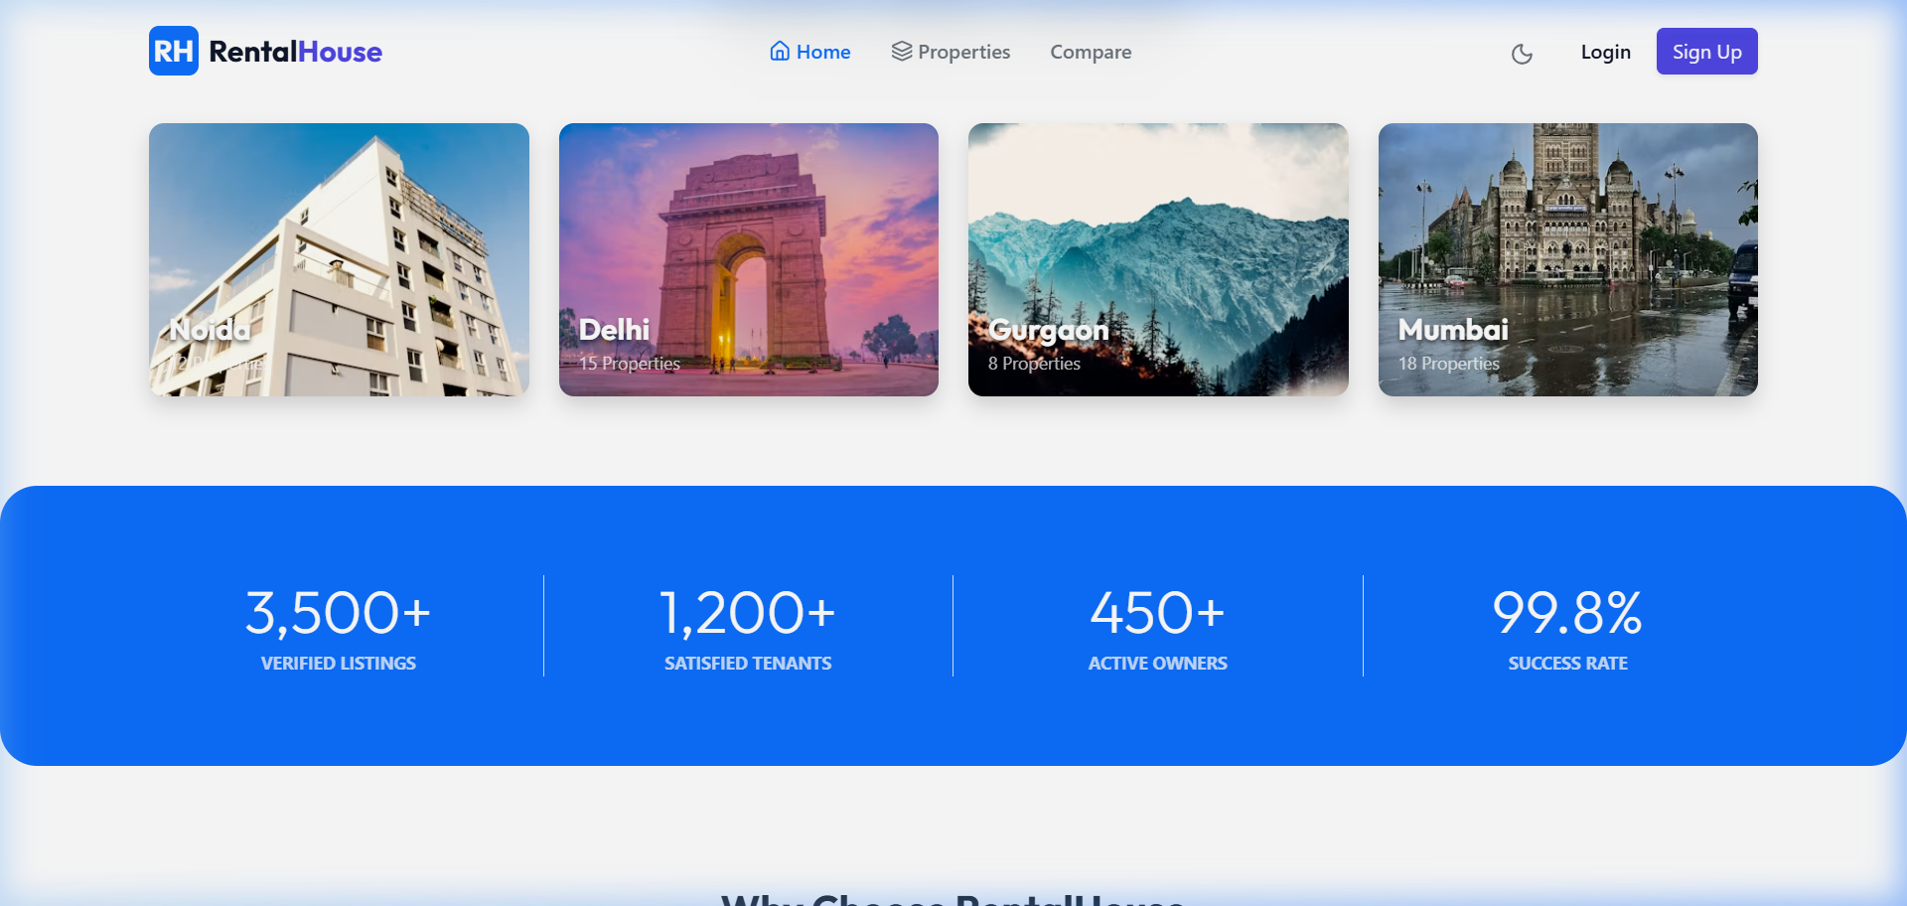

Figure 2: Noida Properties listing filter search (2 properties found)
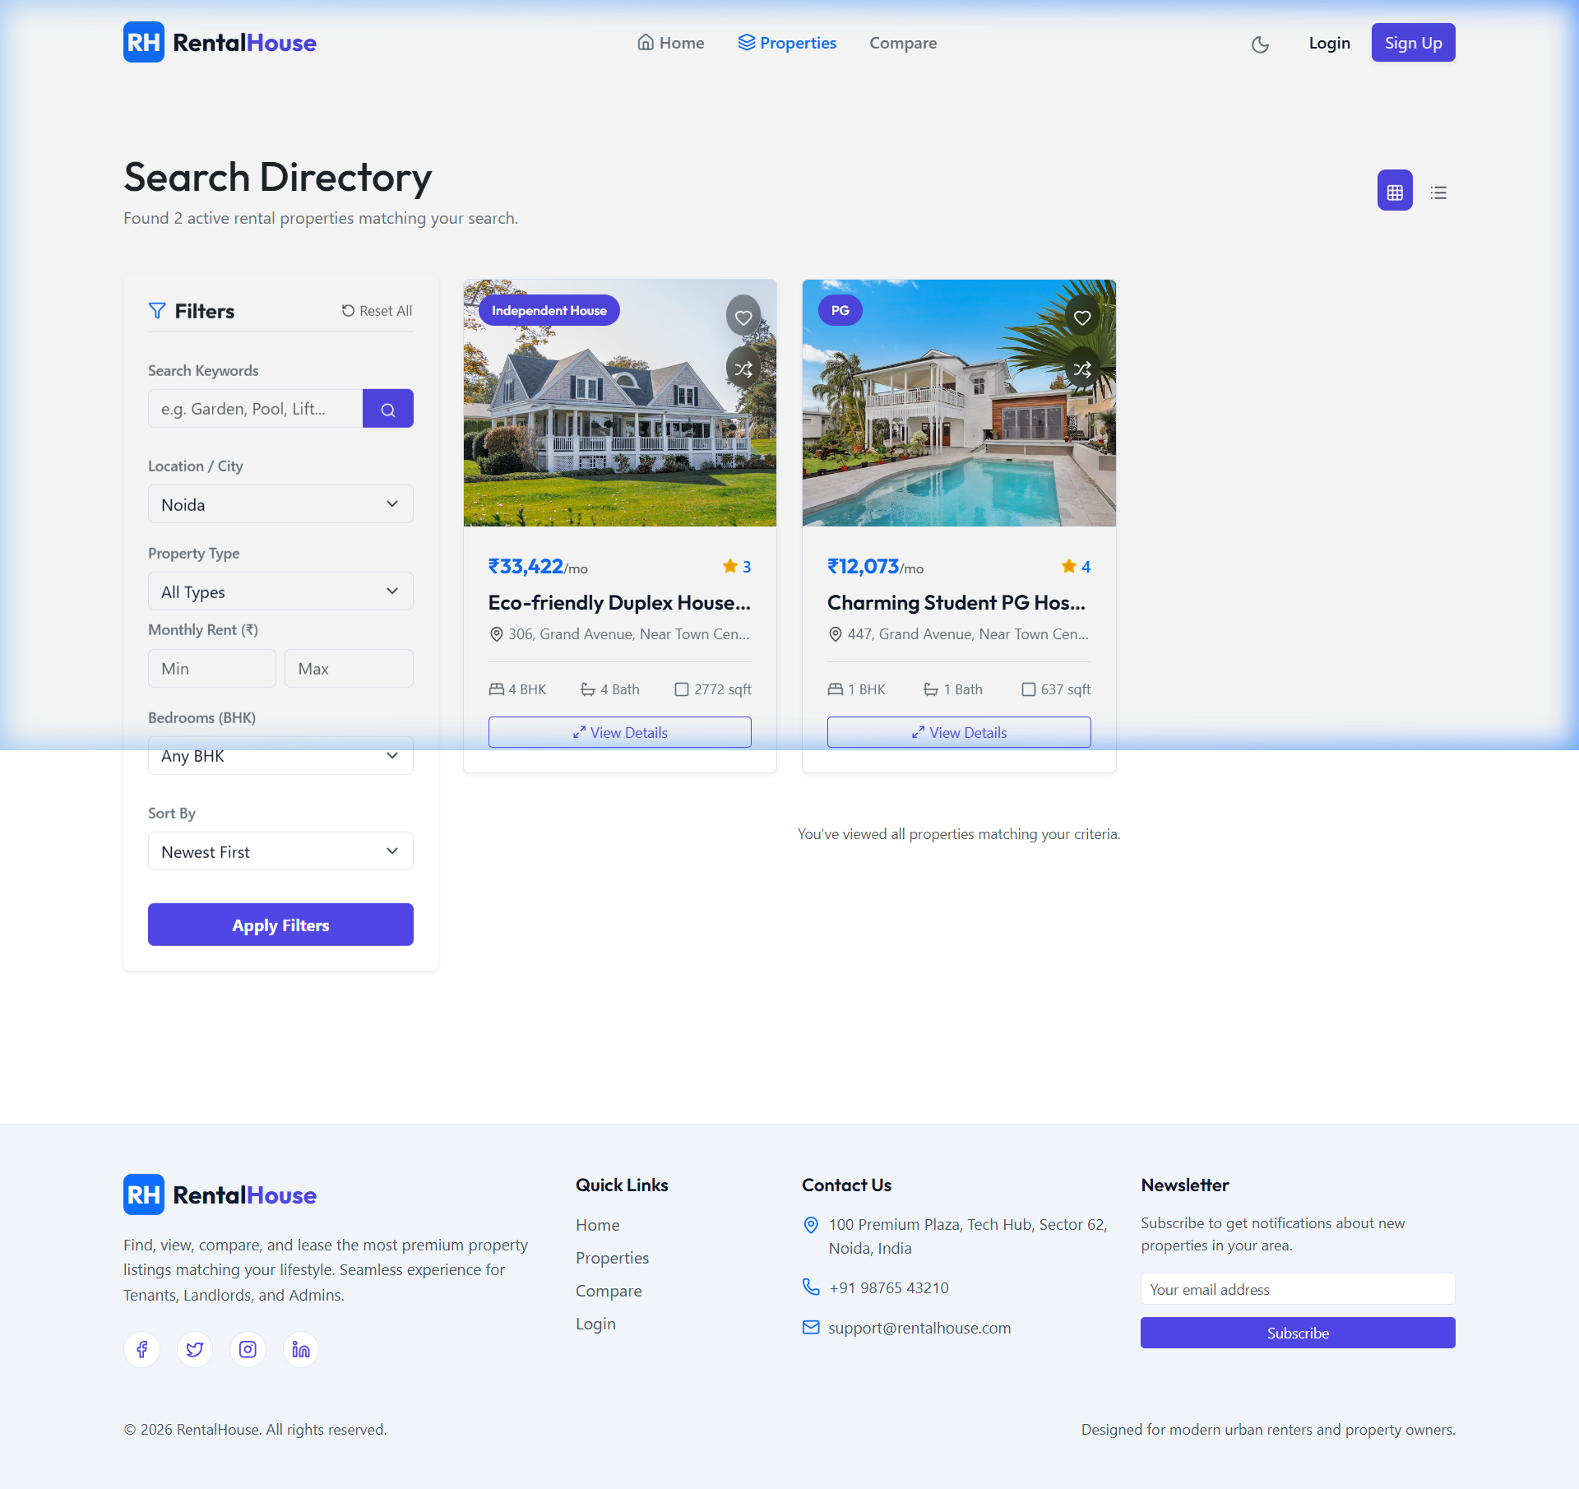

Figure 3: Side-by-side Property Comparison matrix (comparing up to 3 listings)
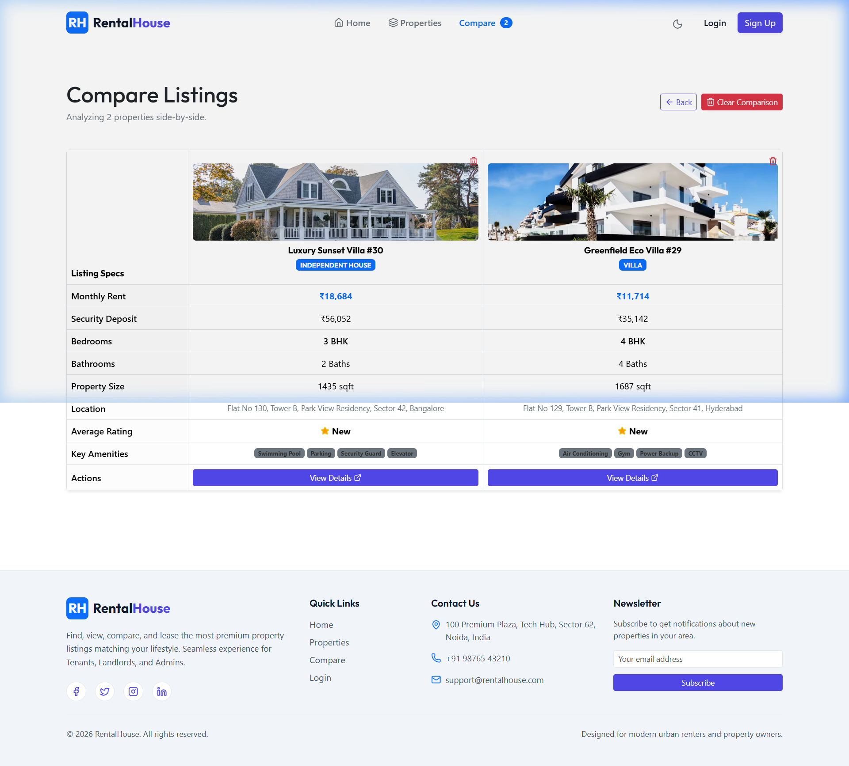

Figure 4: Secure User Login portal
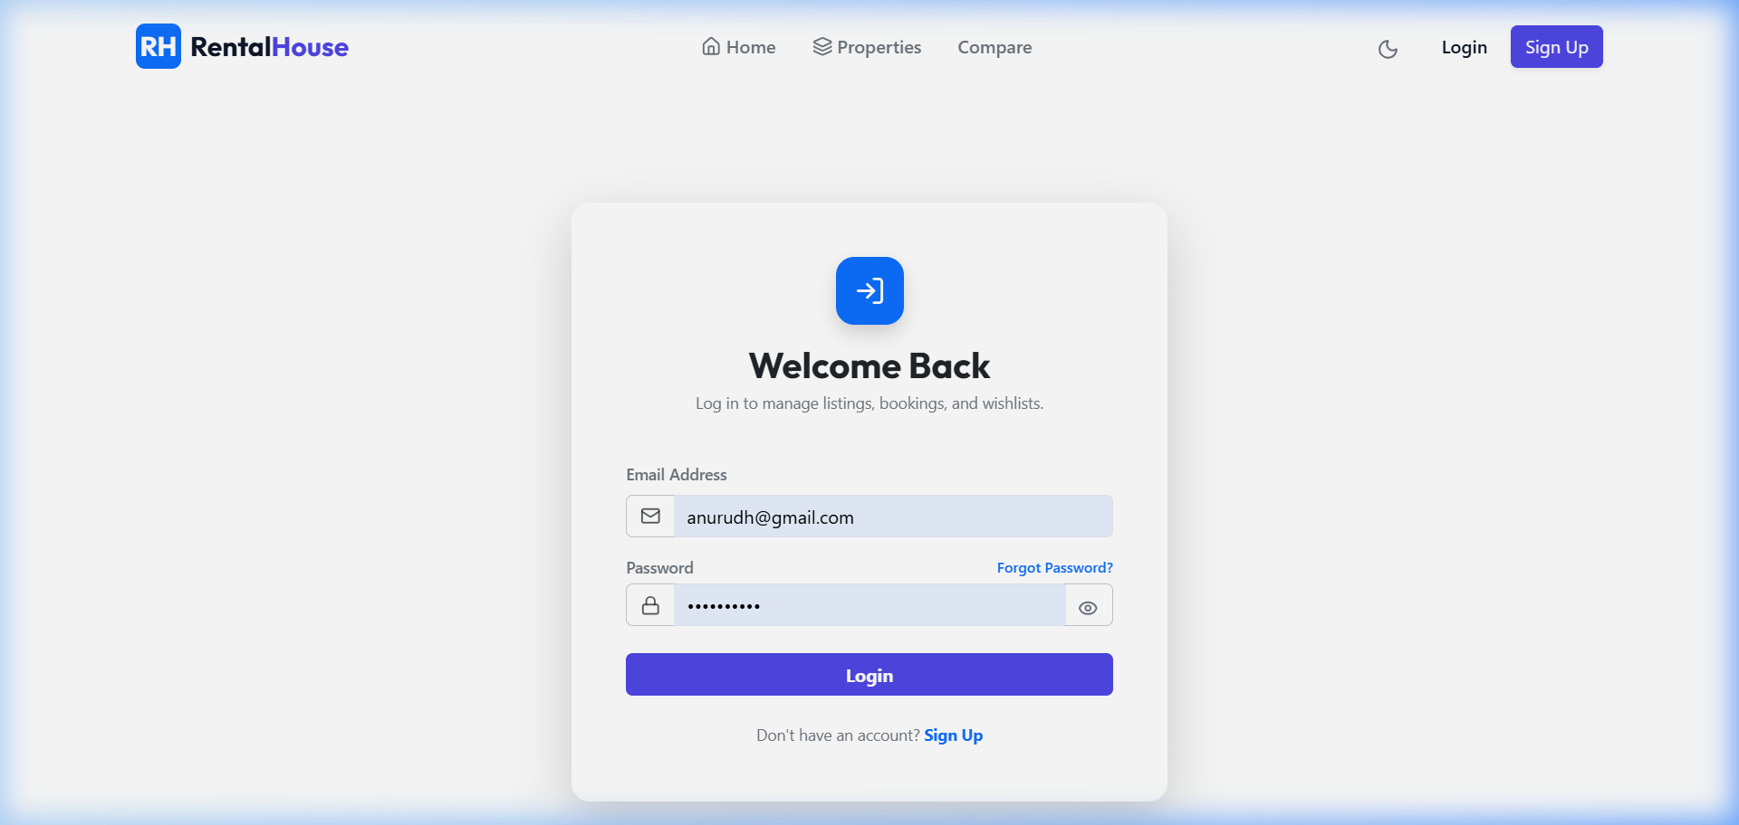

Figure 5: Secure Registration interface
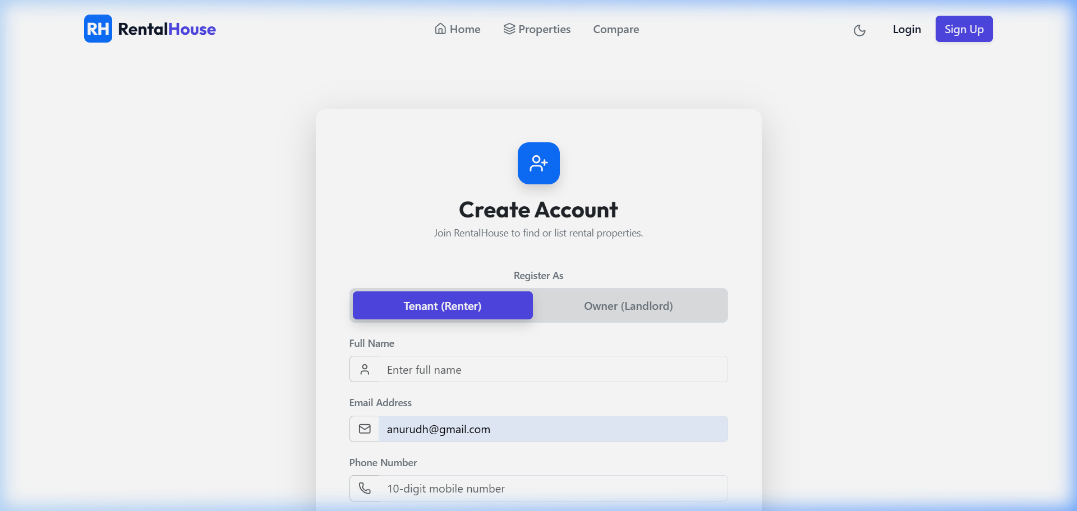

Figure 6: Property details view showing interactive OpenStreetMap widget
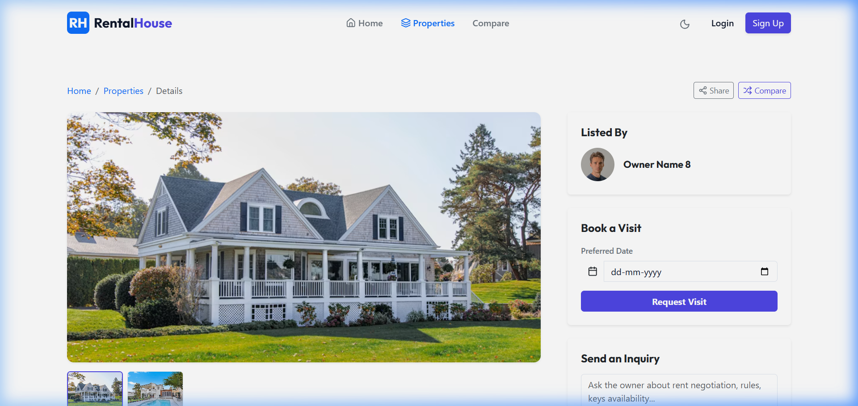

13. Advantages & Limitations
Advantages:
- Direct Communication: Eliminates brokerage fees by letting renters contact property owners directly.
- Visual Discovery: Renders properties locations dynamically, improving area evaluation.
- Comparative Engine: Allows side-by-side listing analytics on rents and deposits, improving decisions.
- System Robustness: Automated local image folders and SMTP log fallbacks ensure the portal works without external API dependencies.
Limitations:
- Storage accumulation: Orphaned property images remain on the server disk uploads/ directory after listings are deleted from the database.
- Database locks: High-concurrency simultaneous booking queries on identical listings can hit race conditions.

14. Future Enhancements
To scale the platform, future development phases will incorporate:
1. Integrated Video Calling: Embedding WebRTC within the dashboard to allow tenants to request live digital viewings with property owners.
2. Stripe Payments: Secure credit-card checkouts for security deposit hold-bookings directly within the app.
3. Twilio SMS Gateway: Automatic text alerts sent to landlords and tenants upon new inquiries or approval logs.
4. Disk Cron Cleanup: Automated scripts running on server cycles to check and remove unreferenced uploads from the server filesystem.

15. Conclusion
The 'Rental House' portal successfully digitizes the residential leasing and listings moderation workflow. By establishing role-based dashboards, secure JWT session verification, static document mapping, interactive map pins, and an admin verification gate, the application eliminates middlemen broker costs and prevents fake listings fraud. The project proves how MERN stack development can create modular, secure, and highly performant full-stack systems.

16. References
1. React Documentation: Official guides on hook architectures and Context states. (https://react.dev)
2. Express Framework: Endpoint routing, controllers mounting, and middlewares. (https://expressjs.com)
3. Mongoose ODM: Document schemas, modeling indexes, and populate queries. (https://mongoosejs.com)
4. JSON Web Tokens: JWT structures and Bearer authorization tokens. (https://jwt.io)
5. OpenStreetMap & Leaflet: Coordinate maps styling and map markers. (https://leafletjs.com)

17. Source Code
Below are the code snippets of the core files of the Rental House platform:
server/app.js: Server Configuration & Routing Mounting
const express = require('express');
const path = require('path');
const cors = require('cors');
const helmet = require('helmet');
const connectDB = require('./config/db');
// Route files
const authRoutes = require('./routes/authRoutes');
const propertyRoutes = require('./routes/propertyRoutes');
const inquiryRoutes = require('./routes/inquiryRoutes');
connectDB();
const app = express();
app.use(helmet({ contentSecurityPolicy: false, crossOriginResourcePolicy: false }));
app.use(cors({ origin: '*', methods: ['GET', 'POST', 'PUT', 'DELETE'] }));
app.use(express.json());
app.use('/uploads', express.static(path.join(__dirname, 'uploads')));
app.use('/api/auth', authRoutes);
app.use('/api/properties', propertyRoutes);
app.use('/api/inquiries', inquiryRoutes);
// Root endpoint
app.get('/', (req, res) => {
res.status(200).send('RentalHouse Backend API is running successfully. Please access client at port 3000.');
});
module.exports = app;
client/src/context/PropertyContext.jsx: Frontend Filter & Fetch API
import React, { createContext, useState, useContext } from 'react';
import API from '../api/axiosConfig';
const PropertyContext = createContext();
export const PropertyProvider = ({ children }) => {
const [properties, setProperties] = useState([]);
const [filters, setFilters] = useState({
city: '', propertyType: '', minRent: '', maxRent: '', bedrooms: '', search: '', page: 1
});
const fetchProperties = async (reset = false) => {
try {
const pageToFetch = reset ? 1 : filters.page;
const params = { ...filters, page: pageToFetch };
Object.keys(params).forEach(key => {
if (params[key] === '') delete params[key];
});
const response = await API.get('/properties', { params });
if (response.data.success) {
setProperties(reset ? response.data.data : prev => [...prev, ...response.data.data]);
setFilters(prev => ({ ...prev, page: pageToFetch + 1 }));
}
} catch (err) {
console.error(err);
}
};
// context values returned...
};

